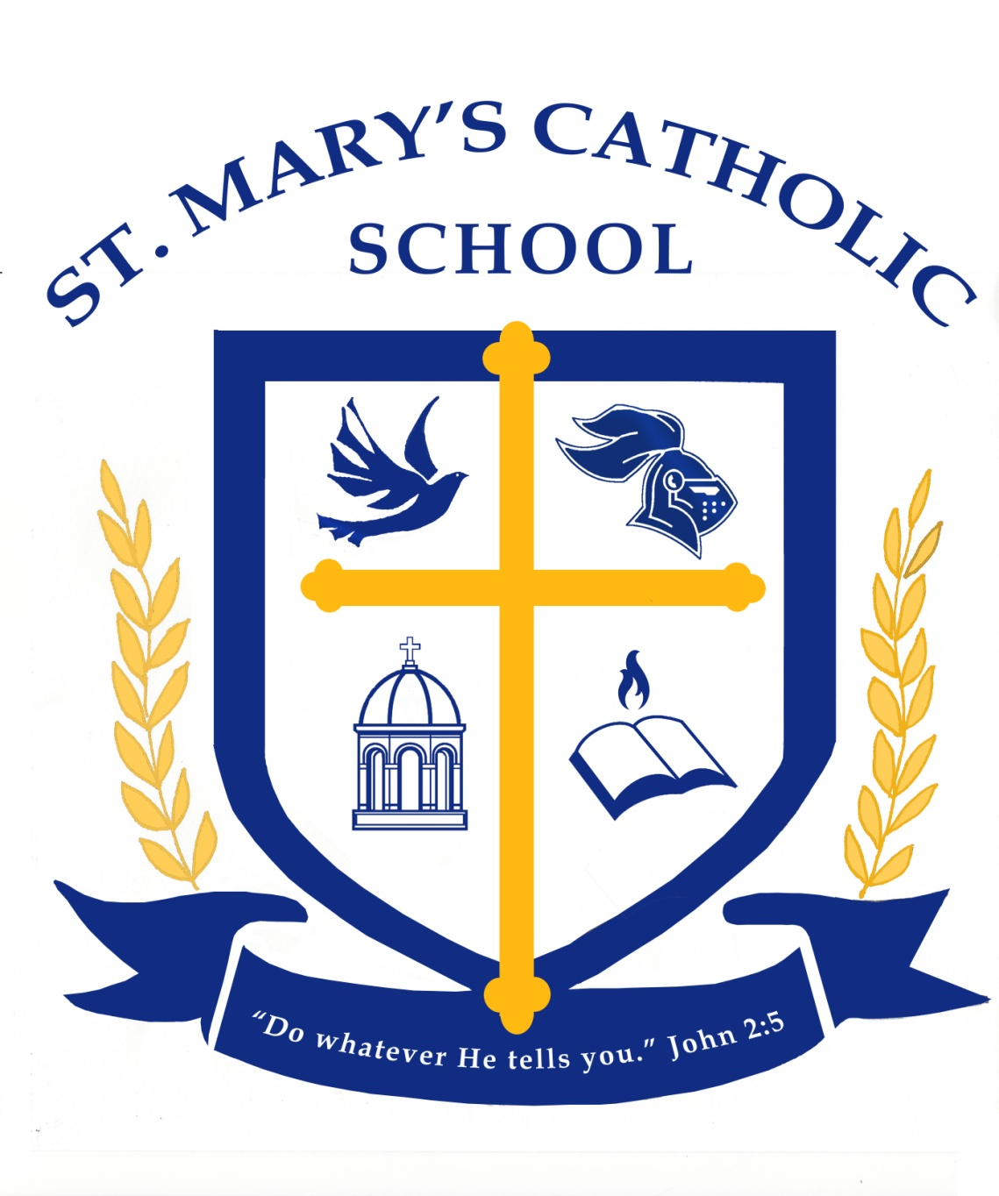

2016 -2017
Wellness Policy
For

St. Mary’s Catholic School

Rationale:
St. Mary’s Catholic School is dedicated to the education of the whole child, spiritual, intellectual and physical. However, so much of our energy is focused upon the spiritual, intellectual, and safety of children; that issues of nutrition and exercise sometimes do not receive the attention they deserve. Our mission is to balance all of those needs for the good of each child entrusted into our care.

The link between nutrition, physical activity and learning is well documented. Healthy eating and activity patterns are essential for students to achieve their full academic potential, full physical and mental growth, and lifelong health and well-being. Healthy eating and physical activity are essential for healthy weight, are also linked o reduced risk for many chronic diseases, such as Type 2 diabetes. Schools have the responsibility to help students learn, establish, and maintain lifelong, healthy eating and activity patterns. Well-planned and effectively implemented school nutrition and fitness programs have been shown to enhance students’ overall health, as well as their behavior and academic achievement in school. Staff wellness is an integral part of a healthy school environment, since school staff can be daily role models for healthy behaviors.

Goals:

St. Mary’s Catholic School is committed to providing a school environment that enhances learning and development of lifelong wellness practices.

All students in St. Mary’s Catholic School are encouraged to adopt healthful eating and physical activity choices for a lifetime.

All staff in St. Mary’s Catholic School are encouraged to model to students healthful eating and physical activity as a valuable part of daily life.

To meet these goals, St. Mary’s Catholic School adopts this wellness policy with the following commitments to nutrition, physical activity, comprehensive health education, marketing and implementation. The intent of this policy is to effectively use school and community resources and to equitably serve the needs and interests of all students and staff, taking into consideration differences in culture.

Additional St. Mary’s Specific Goals:
- A higher percent of students will attend breakfast and lunch as provided by St. Mary’s through the School Nutrition Program.
- Students, after being measured for body fat, will, through their P.E. program, work towards a reduction of their overall body fat.
- We will limit Calories:
  - Snack items: < 200 calories
  - Entrée items: < 350 calories
- We will limit Sodium:
  - Snack items: < 230 mg (200 mg by 2016)
  - Entrée items: < 480 mg
- We will limit Fat:
  - Total fat: < 35%
  - Saturated fat: < 10% of calories
  - Trans fat: zero grams
- We will limit Sugar:
  - < 35% of weight from total sugars in food

To Accomplish these goals St. Mary’s Catholic School will:

- offer school meal menus (lunch, breakfast, snack) that meet the meal patterns and nutrition standards established by the U.S. Department of Agriculture and the Oklahoma Department of Human Services, School Nutrition Programs;
- provide and promote sequential and interdisciplinary nutrition education;
- provide physical education and physical activity;
- ensure that all school-based activities are consistent with Archdiocesan wellness policy goals;
- will teach proper nutrition when appropriate, in religion class, physical education, science class, health, and whenever possible.
- In addition, St. Mary’s will advertise the breakfast and lunch programs on a regular basis in the school newsletter, Mary’s Messenger.
- Through a robust physical education program with health related lessons on nutrition, St. Mary’s will assist students in being more health conscious, so as to combat childhood obesity.

St. Mary’s Catholic School will:

- teach students that their bodies are a gift from God, and we are all are called to take care of our selves through healthy eating and exercise;
- promote health and nutrition in other school-based activities (such as school events, field trips, dances, assemblies, fundraisers, and sports events).
- promote care for our bodies by hosting fairs, theme weeks, and guest speakers promoting a healthy lifestyle;
- organize and participate in a local health committee comprised of families, teachers, administrators, and students to plan, implement, and improve nutrition and physical activity in the school environment.
  - Health Committee is comprised of Nancy Post, Principal; Elizabeth Little, Cafeteria Manager; and Robin Hamilton, P.E. Teacher.

Nutrition Guidelines for All Foods on Campus

St. Mary’s Catholic School will:

- establish guidelines for all foods available on campus during the school day with the objective of promoting student health and reducing childhood obesity;
- promote healthy and nutritious foods offered by vending machines, a la carte, beverage contracts, fundraisers, concession stands, student stores, and school parties.

Nutrition Guidelines for All Foods on Campus Cont.

St. Mary’s Catholic School will:

- add nutritious and appealing options (such as fruits, vegetables, nuts, trail mix, beef jerky, reduced-fat milk, reduced fat-yogurt; reduced-fat cheese, 100% juice, and water whenever foods/beverages are offered at the site;
- request from food vendors healthy and nutritious alternatives to current food products such as snack and beverage choices;
- provide healthy options to current snack and beverages found on the lunch line, in vending machines, in student stores and concession stands;
- involve parents and staff in identifying nutritional and healthier food options;
- promote healthier food items by advertising in classroom and cafeteria lines;
- follow USDA, Child Nutrition Programs policies on competitive foods and extra food sales.

Implementation:

The Archdiocese of Oklahoma City will:

- use the accreditation standards to assess implementation of the school wellness policy;
- principals will review lesson plans to insure students are receiving instruction in the areas of nutrition and physical fitness.
- encourage school participation in the Wellness Coalition through Chance to Change to address issues of wellness, nutrition and health;
- through the wellness coalition offer a yearly assessment with regard to school progress in the areas of nutrition, health, and wellness;
- assessment data collected through the Wellness Coalition, will be used to generate a yearly report that will be submitted to the Catholic School office for the purpose of insuring implementation and progress in the areas of nutrition and prevention of childhood obesity;

Wellness Coalition / School Health Committee Membership

Catholic Charities / St. Joseph Counseling Center
Chance to Change
Mercy Hospital
St. Anthony’s Hospital

Wellness Coalition / School Healthy Committee Membership cont.

COAD-HI
Oklahoma Department of Human Services
Oklahoma Department of Mental Health
Public Strategies
Principals, teachers and counselors from schools in the Archdiocese of Oklahoma City
Student Representatives from Catholic Schools of the Archdiocese of Oklahoma City
Associate Superintendent of Catholic Schools

St. Mary’s Catholic School Wellness Committee
Nancy Post, Principal
Elizabeth Little, Cafeteria Manager
Robin Hamilton, P.E. Teacher

Nondiscrimination Disclaimer
The U.S. Department of Agriculture (USDA) prohibits discrimination against its customers, employees, and applicants for employment on the bases of race, color, national origin, age, disability, sex, gender identity, religion, reprisal and, where applicable, political beliefs, marital status, familial or parental status, sexual orientation, or if all or part of an individual's income is derived from any public assistance program, or protected genetic information in employment or in any program or activity conducted or funded by the Department. (Not all prohibited bases will apply to all programs and/or employment activities.)
If you wish to file a Civil Rights program complaint of discrimination, complete the USDA Program Discrimination Complaint Form, found online at http://www.ascr.usda.gov/complaint_filing_cust.html, or at any USDA office, or call (866) 632-9992 to request the form. You may also write a letter containing all of the information requested in the form. Send your completed complaint form or letter to us by mail at U.S. Department of Agriculture, Director, Office of Adjudication, 1400 Independence Avenue, S.W., Washington, D.C. 20250-9410, by fax (202) 690-7442 or email at program.intake@usda.gov.
Individuals who are deaf, hard of hearing, or have speech disabilities and wish to file either an EEO or program complaint please contact USDA through the Federal Relay Service at (800) 877-8339 or (800) 845-6136 (in Spanish).
Persons with disabilities who wish to file a program complaint, please see information above on how to contact us by mail directly or by email. If you require alternative means of communication for program information (e.g., Braille, large print, audiotape, etc.) please contact USDA's TARGET Center at (202) 720-2600 (voice and TDD).
USDA is an equal opportunity provider and employer.

.

